Amble

Notice the Weekly Plan and the shopping list on the right side.
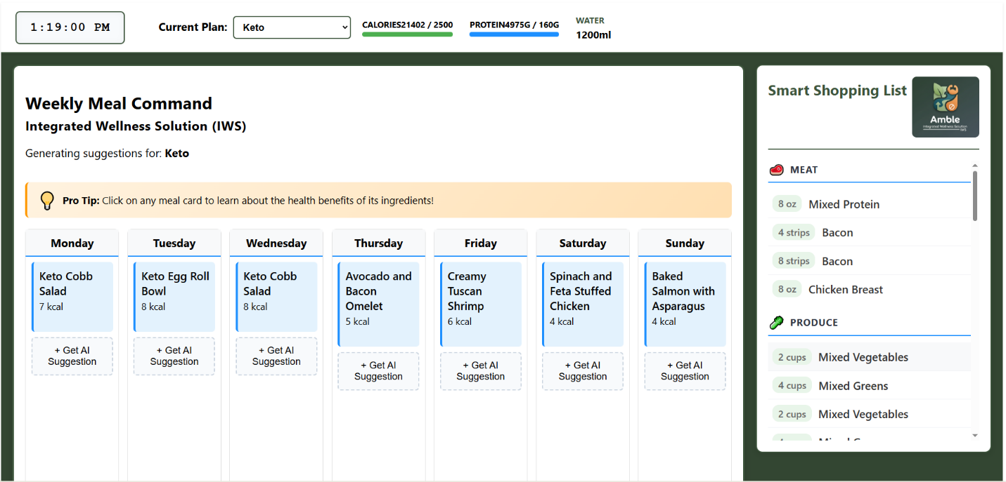

This appears when you click on any Meal Plan.
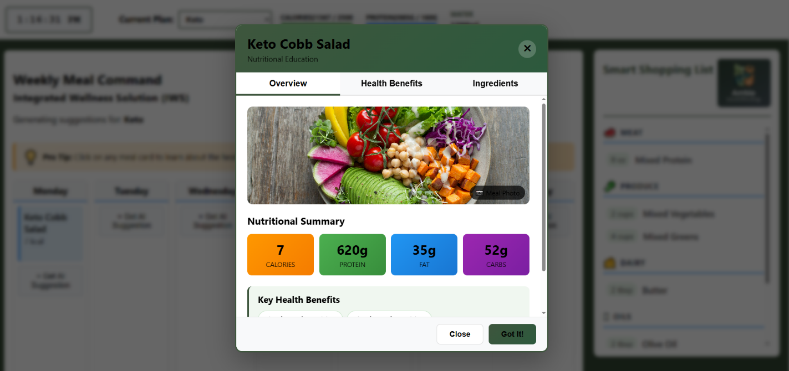

My favorite is the Health Benefits of each meal.
